Careers Education, Information, Advice and Guidance
CEIAG
St Bede’s prides itself in preparing students for the next stage of their life, not only academically but in relation to future career pathways. Where ‘career’ was once thought of as a single commitment to a lifelong occupational pursuit, it is now thought of as a lifelong journey whereby individuals participate in differing learning and work roles. At St Bede’s we hope to contribute to and prepare young people for that journey.
The Progression Manager, Anne Jukes will manage the careers education programme and is responsible to the Assistant head teacher & Director of 6th Form, Mrs E Graham.
CEIAG is supported by a link Governor: Mr D. Dixon. Work experience is planned and implemented by the school which works closely with North Yorkshire Business Enterprise Partnership to source and monitor these placements.

We have relevant Careers Education modules built into our PHSE programme from Year 7 through to 6th Form which draw upon many visiting speakers from local organisations, FE Colleges and Universities.
Within our programme students:
- Learn about the structures, systems and factors that guide, shape and influence people’s career prospects and career development
- Explore how these could affect their future choices, why they need to consider them when making their own career decisions and plans, and how they can do so
- Develop and practice the self-help skills they need to progress their own career plans and development, including the effective use of IAG (Information, Advice & Guidance)
​
Careers Information – students have access to accurate, up-to-date and objective information on opportunities, progression routes, choices, where to find help and advice and how to access it. We work in partnership with local colleges and employers to ensure students have access to the best opportunities in the career market. We also use relevant Labour Market Intelligence data to help students make informed choices.
Careers Advice – We have a range of activities that help young people to gather, understand and interpret information and apply it to their own situation. For example, we have a Careers Carousel events for every year group from Y7 to 6th Form and a Careers Convention in Year 12 which allows students to discuss careers with industry ambassadors from a vast range of sectors, Colleges and Universities.
Careers Guidance – we provide impartial guidance and specialist support to help young people understand themselves and their needs, confront barriers, resolve conflicts, develop new perspectives and make progress. All Year 11 students have a one-to-one Progression Interview with our Progression manager, Anne Jukes, to prepare them for post 16 choices. All other year groups can book appointments or drop-in during break or lunchtimes or free periods to access IAG.
​The careers programme includes: careers education sessions, career guidance activities (e.g. group work and individual interviews), information and research activities using the school computer network and work related learning, work experience, and individual learning planning/portfolio activities.
Careers lessons are part of the school’s personal development programme. Other focused events, e.g. a further/higher education fair are provided at different times of the year. Work experience preparation, debrief and evaluation take place in PSHE/careers lessons and other appropriate parts of the curriculum. Learners are involved in the planning of career learning. Their views are collected using student voice/surveys.

Impact of CEIAG
At St Bede’s we judge the impact of CEIAG through
- examining & evaluating what we do,
- thinking about how we can improve it,
- deciding on whether it was worth doing again in that particular format (we pilot many activities before extending to full scale),
- providing summaries to disseminate understanding of what was done to stakeholders such as parents/students/staff/governing body/visiting organisations involved with careers events.

Careers Work within PSHE
Each section of careers work is introduced in relation to preparing students for the future as below

CHECKLIST for your future -The six capabilities for work
1.Self-aware | - Take responsibility for yourself and others  - Exhibit self-control  - Be accountable for your actions  - Do not shift blame  - Recognise your own strengths and weakness
2.Receptive | - Be willing to address weaknesses  - Take feedback and advice  - Be open to new ideas and working in different ways  - Be open-minded, patient and flexible
3.Driven | - Display a positive attitude  - Apply yourself consistently  - Be reliable, motivated, punctual, well-organised, hard-working  - Go the extra mile
4.Self-assured | - Have good levels of self-esteem  - Be willing to ask questions and seek more information  - Be prepared to work alone without clear direction  - Be prepared to work effectively within teams  - Display signs of self-esteem
5.Resilient | - Learn to cope with rejection and set-backs  - Learn from mistakes  - Be open to constructive criticism,  - Be determined to overcome obstacles  - Persevere and do not panic under pressure
6.Informed | - Have an understanding of the jobs market  - Display an ability to search for job vacancies and complete background research  - Understand office etiquette  - Be well-presented  - Be effective in describing your achievements verbally and have a representative CV | 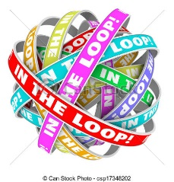

Work-readiness
- Make sure you are fully informed about the sectors you are interested in working in
- Familiarise yourself with the most up-to-date labour market information.
- Speak to a professional in the career area you want to be in –it may lead to work experience
- Talk to your family, friends and neighbours they may have contacts
- Even if experience is not directly relevant to the career path you wish to pursue, it can provide an opportunity to develop transferable skills described above.

Years 7- 11 Careers Programme
Year Group | Term | Areas Covered within PSHE- STEPS Programme | Additional support
7 | Term 2  February | - What influences me  - Roles that are successful  - Your own personal qualities  - Skills for life/life roles  - How to learn  - Describing yourself to others (skills/likes/dislikes/ambitions)  - What is work? /Changes in the World of Work  - Setting personal targets | - INSPIRED IN4 Briefing- Oh the places you’ll go  - The skills Gap presentation in preparation for Sector Skills Day  EVIDENCE of IMPACT  - Staff & Student Evaluation  - Staff analysis/training need record
8 | Term 2 January | - Personal qualities & Jobs  - Skills & Jobs  - Working Today  - Qualifications  - Choosing Options | - The skills Gap presentation in preparation for Sector Skills Day  - Options preparation  EVIDENCE of IMPACT  - Staff & Student Evaluation  - Staff analysis/training need record  - Option Choices/ student choices in relation to future pathways
9 | Term 3  April | - Your Beliefs  - Are school and work so different?  - What do you want from work?  - Which job goes where?  - You are in charge?  - They said What?  - Being assertive  - Who does the job?  - Are you sure that’s true?  - Budgeting  - How do you make decisions?  - Writing an action plan | - World of Work Day  EVIDENCE of IMPACT  - Staff & Student Evaluation  - Staff analysis/training need record
10 | Term 4  May | - Exploring possibilities  - The World of work  - Application skills  - Developing your personal sales pitch  - Managing your money  - Thinking ahead after Year11  - Different Qualifications | - Post 16/18 Options Presentation  - Informed Decisions Day  - Progression Interviews  EVIDENCE of IMPACT  - Staff & Student Evaluation  Staff analysis/training need record  - Students understanding of Post16/18 option pathways
11 | Term 1 September | - Year 11 Planner  - How are you doing?  - Skills & Interests  - What are you like?  - Qualifications  - Which way to go Post 16  - The changing Job Market  - Personal, Learning & Thinking Skills  - Money Matters  - Choices Now & Later  - Making Applications  - Where have you got to so far? - explaining preferences & decisions/ back-up plans | - Personal Best Day  - Progression Interviews  - Post 16 Route Update Interviews  - Application support  - FE College Visits  EVIDENCE of IMPACT  - Staff & Student Evaluation  Staff analysis/training need record

Sixth Form Careers Programme
Within St Bede’s, Sixth Form students are in mixed year 12/13 Tutor Groups. The rationale behind this is to support their next transition stage and shows students they can progress.
- It allows students peer support& peer mentoring
- It develops leadership and teamwork
- It de-polarises behaviour in the tutor group
- It creates a more supportive ‘family atmosphere’. and promotes prosocial behaviour
- It enables to students to start to experience mixing with different age groups in preparation for the working environment or University.
- It allows for richer and more varied non-academic learning activities
- It allows tutors to give much better, more personalised support to their tutees, due to the reduced numbers of students at any given stage of their preparation for transition.

In addition to the activities below with have other enrichment activities to support and enhance our students
holistic development
General studies/ EPQ  - British Values  - Business Ethics  - Current Affairs  - Political affairs  - World awareness |  |  | Volunteering/Sport/Enrichment  - Sporting activities with Year 7  - World Challenge events  - Reading buddies Year 7  - Duty Positions  - General Sports  - Ambassador duties  - Mooc’s /Vooc’s  - Year 12 Subject Link duties
Sixth Form | Term 1 | - Links with Widening Participation Schemes at local/national universities (NU Entry- Northumbria University, First Choice- Sunderland University, Partners- Newcastle University)  - UCAS Preparation/ Monitoring- Y13  - ILP- Y12  - Reading for Meaning- Cornell note taking  - The Successful Sixth Former-Research Skills/ Getting Organised/Using Sources/ Essay Writing Skills  - Time Management  - Pope John Paul 11 Award  - Mindfulness  - Student Finance  - Interview Skills  - Enrichment Carousel-Revision Skills/Public Speaking/Research Skills/Cultural awareness  - Community Engagement-Hamper prep & delivery |  | - Personal statement Clinic  - Work experience support programme  - Work experience ideas Generator  - Global Bridge Programme  EVIDENCE of IMPACT  Termly Student Review
Sixth Form | Term 2 | - Tutor Reviews  - Pastoral reviews  - Critical Friend file + organisation  - Revision Sessions  - ILP Updates  - Debate preparation  - Debate  - Carousel  - RSE  - SMSC  - Money Matters  - Careers |  | - Inspiring Women Programme  - Training Provider/apprenticeship Drop-ins  - Apprenticeship Assessment Centre Workshops  - UCAS Interview support  - Apprenticeship Interview Support  EVIDENCE of IMPACT  Termly Student Review
Sixth Form | Term 3 | - Revision Y13  - Revision Strategy review- Y12  - Leavers Celebration of success- Y13  - Enrichment-Y12 |  | - Apprenticeship Interview Support  - Year 12 Work experience  - Year 12 Careers & UCAS Convention  Including parents event.  EVIDENCE of IMPACT  Termly Student Review  Parent Feedback from Careers Convention

Careers Events within School
Event/Date | Event Description | Evidence of Impact
All of the whole -day carousel events in our main hall have an opportunity for visitors to access students at break and lunch-time through Whole-School Drop-in’s whilst in school. Staff and students are made aware of the opportunities in advance of the event in order to support students to access the event.
Term 1- September/ October  Year 13 Personal Statement Support | This Lunch-Time Drop-in event is to help students boost their success in university applications by gaining some expert advice from our local HE providers.  Students can bring along their statements to get advice and tips on how to improve and refresh them before deadline day. | - Quality of Personal statements  - Success of applications to university  - Destination Data- including offers/ DCC data  - Visitor Feedback
Term 1 - October  Year 11 Personal Best Day  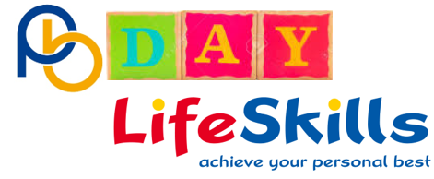 | This carousel Event is specifically aimed at essential Career Management Skills.  Interviews, CV’s/ Covering Letters. presentation skills, personal branding etc.  Its an opportunity for students to draw together all of their experiences of careers work over their time with St Bede’s and create the necessary passport for their next transition | - September guarentee  - Intended Destination Data  - NEET figures  - Destination Data- DCC  - Student Evaluation  - Visitor Feedback
Term 1 October  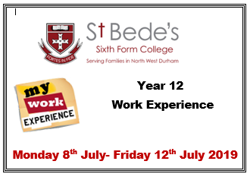  Year 12 Work Experience Launch Presentation | Work Experience Provider NYBEP (North Yorkshire Business Enterprise Partnership) will launch the programme with our Year 12 students.  Students encouraged to find their own placement, as part of their personal development, and use NYBEP to Health & Safety check the placement organisation.  Any student without a placement will then be helped by NYBEP to find a placement linked to their programme of study or future Career choice | - Link to career choice & POS  - NEET data  - NYBEP evaluations  - Employer Feedback  - Student feedback  - Parent Feedback  - Job profile sheets  - Student W/ex log book
Term 1 – October/ November  Year 11 Business Studies Interview Sessions  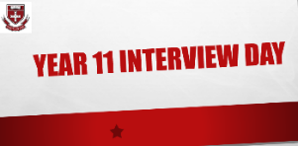 | As part of their Business Course students will  - apply to one of the advertised job vacancies by completing the St Bede’s application Form  - prepare by researching the company and looking at types of questioned to be asked  - attend an interview with an external interviewer  - will get feedback from the interviewer which will help you with evidence for their course and prepare them for future . | - Feedback from Interviwers  - Self Evaluatuion students/ coursework for Businees course
Term 1- November  Year 12 Ideas Generator | As part of our work experience programme in Year 12, we encourage our students to look and make arrangements for their own placements. If they fail to find one, we will use North Yorkshire Education Business Partnership to broker a placement on their behalf.  These lunchtime drop-in sessions are aimed to help our young people in Year 12 prepare for finding their work experience placements.  We find sometimes that they have a great love of a subject area and find it really difficult to link that with employment opportunities in the future. | - Quality of applications to Placement provider  - Placement Feedback  - Completed student Job Profile sheets  - NYBEP evaluations
Term1 November  Year 12- Introductory Presentation  GlobalBridge  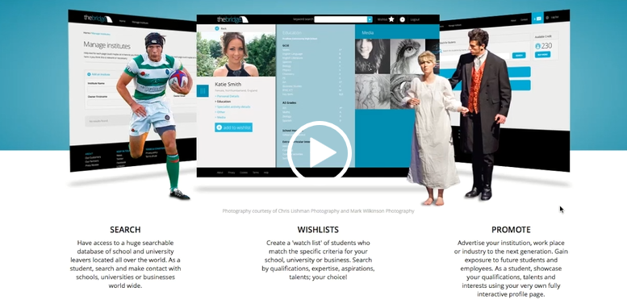 | Globalbridge is a unique platform that bridges the gap between students, universities and employers. The profile allows young people to showcase their talents and achievements to educational institutions and industry, while allowing them to search for schools, universities and businesses that offer the opportunities they are seeking.  It also provides universities and businesses with a searchable, fully customisable database to identify individuals who satisfy specific skills, interests and goals.  We launch this service with our 6th form to ensure they have access to the best opportunities in the future by showcasing their skills and abilities. | - Employer engagement  - Student profiles  - Destination data
Term 1-December  Years 7 & 8 Sector Skills Day | This carousel event is the culmination of work within tutor groups to inform our students about Transferable, Subject Specific and Career Management Skills needed to prepare for work in the 21st Century.  Young people engage in the activities on offer to understand the equipment used & skills needed within different sectors; Students also have access to LMI (Labour Market Intelligence) about the North East and global labour markets.  Our students are made aware of the Skills Gap and what they can do to future proof themselves. | - Student evaluations  - Visitor Feedback
Term 2- January/February  Years 12 & 13- Inspiring Women Programme  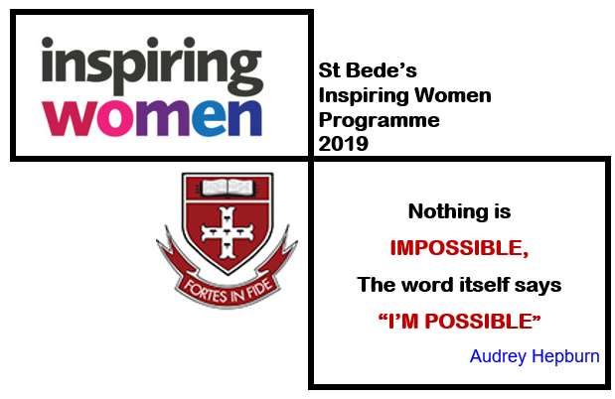 | A series of lunchtime talks from a range of women from various sectors. A chance for our students to be inspired to forge careers in different fields and encouraged to think big in regard to their future aspiration | - Student Evaluation  - Visitor Feedback  - Future Destination choices/outcomes
Term 2 January/February  Year 12/13 pilot  Global Bridge Lunchtime Workshops | Small group workshops to enable students to build their digital profiles and offer personalised support | - Employer engagement  - Student profiles  - Destination data
Term 2- February/March  Year 13 Training Provider Drop-ins  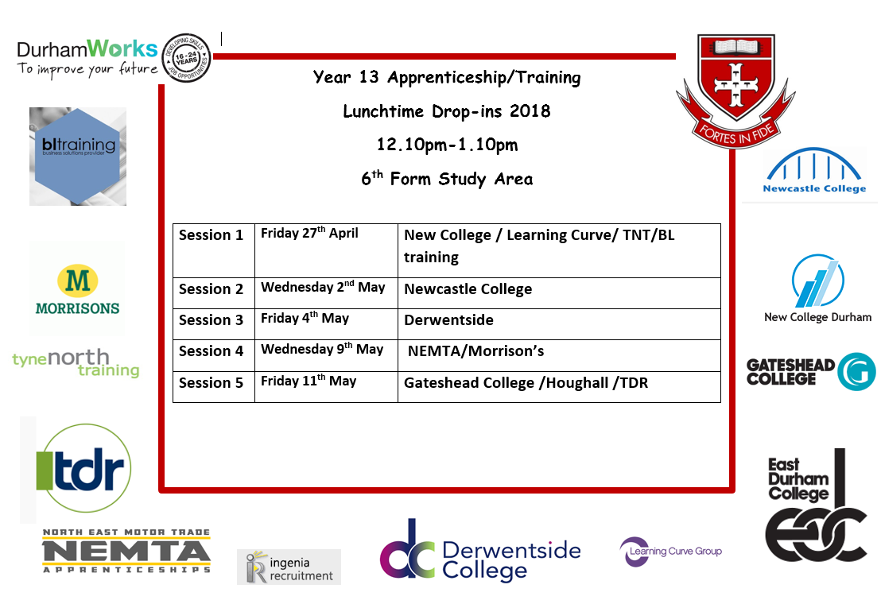 | An opportunity for students to see current apprenticeship/training opportunities and discover other opportunities open to them in the future.  Intended for students looking for higher or degree apprenticeships or to support a back-up plan should they change their mind about their university applications. | - Intended destination/Destination Data  - NEET figures
Term 2 -March  Year 9 World of Work Day  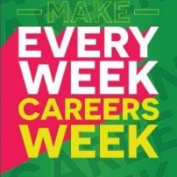  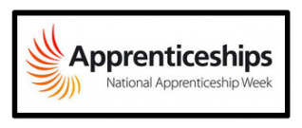  to tie in with National Apprenticeship Week and National Careers Week | The aim is to help our young people understand the wide variety of career sectors available to them in the future and explore where their subject choices could take them in more depth.  A fun active event to encourage students to consider their pathways and how they can best present themselves to employers in the future.  The Carousel-style event offers a chance to engage with visitors in order to understand the qualifications & qualities, but especially the employability skills, needed in each particular industry.  Visitors have a wide range of activities and equipment on hand inspire our students.  Lunchtimes all week Whole -School Drop-in; with an emphasis on Apprenticeships.  Students have a chance to engage with our visitors and explore apprenticeships on offer | - Student Evaluations  - Visitor Feedback  - Returning former pupils/apprentices
Term 3-May  Year 10 Informed Decision Day | A part of a raft of interventions to prepare Y10 students for Post 16 & Post 18 Pathways.  Activities include- Presentation on Pathways, PSHE section on careers, ID Day, Y10 sixth form subject tasters, Taster visits to FE college, NE Skills Exhibition Visit. Individual Progression Manager Interviews.  A variety of Post 16 and Post 18 pathways are represented at the carousel event which encourages our students to consider different pathways. | - September guarantee  - Intended Destination Data  - Destination Data- DCC  - Student Evaluations  - Visitor Feedback
Term 3 -June  Employability Day  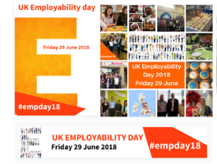 | Employability Day is an event organised by ERSA (Employment Related Services Association) for the employment support sector and employers to join together and show what employability support means at the frontline and the impact it is having in the local area.  As part of that initiative St Bede’s will be engaging in some activity within the classroom setting looking at career management skills to support transferable and sector specific skills with all of our students which further underpins our work within PSHE.  In addition, we would like to invite some of our partner organisations to support a lunchtime CV Clinic with our young people. There will be a variety of starting positions with our young people- Year 7 may need to understand what a CV is whereas Year 12 may need to update theirs to reflect best practice in different sectors. | - September guarantee  - Intended Destination Data  - Destination Data- DCC  - Student Evaluations  - Visitor Feedback
Term 3-July  Y12- Careers & HE Convention  July – after students have returned from Work Experience | Future Proofing our next generation  Year 12 students have a two-day intensive programme to help them become future ready for Post 18 pathways.  Visitors from universities, colleges and training providers aid school Progression Staff and Tutors to deliver a range of workshops and talks to help our young people prepare for their next steps after school.  We were are joined by past students to give their perspectives on preparing for university, university life, careers and enterprise.  The event also includes a two hour Post 18 carousel of activities in the main hall to kick start the event and actvively engage students in their own research and learning.  Activities have included  - “An Introduction to Foundation Degrees / HND / Professional Qualifications”- How these can be delivered at university or FE Colleges. Course Structures and application procedures  - “Personal Branding”-How to deliver your personal brand and unique selling points  - “The variety of different types of University Interview” and how to approach them. Additional information on the range of courses requiring knowledge, skills or experience and why this is important, courses with different types of interviews, the ‘what else can you offer’ factor!  - “Investigating Future Progression Pathways-Resources to help”. Online and web based resources to aid students’ research and applications.  - “Post 18 Pathways- Taking all options into consideration” including Degrees, Foundation degrees/HNC/HND’s, Apprenticeships, GAP years etc.  - “Intro to UCAS” – understanding the application process.  - “Finance, Scholarships and Bursaries”- finance needed, how to access and help available  - How to write a good personal statement- how to avoid common mistakes and miss out on offers?  - “Applying for university and life after school” from the perspective of students/ past pupils | - Intended Destination Data  - Destination Data- DCC  - Student Evaluations  - Visitor Feedback  - Returning former pupils to support event  - Parent evaluation of evening event
Y13 – Future Proofing Project  Throughout Year13  Adhoc arrangements to suit students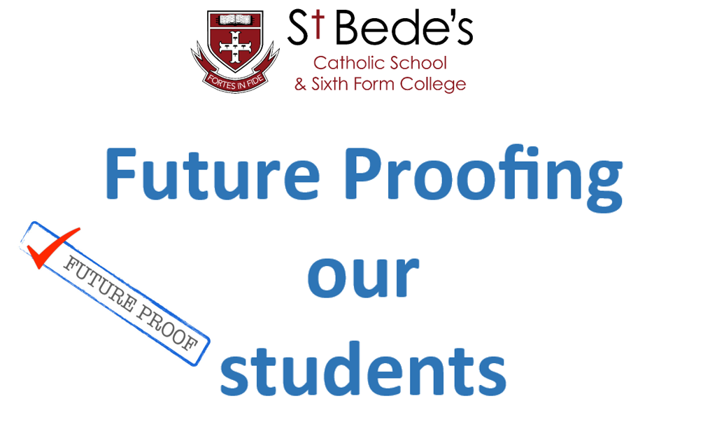 | The Futureproofing our Students Project  A programme of mock interview sessions for our 6th form students.  We have a wide variety of end-destinations and occupational areas that our students progress into, so we will need a variety of organisations / Industries to take part.  It is hoped, that after early canvassing of our students, we could identify areas they would like to work-in Post 18 and Post University.  Some students may not have an interview for university and may not encounter one until after university so we feel it is necessary to prepare them at this stage to ensure their future success.  We may also need people to help with university style, apprenticeship or occupational interviews | - Intended Destination Data  - Destination Data- DCC  - Student feedback after mock and final interviews  - Interviewer feedback
Whole School  Year7- Year13  Term 1- October  Term 2- January/February Term 3- May | Once per term, lecture theatre slot across Period 4 PSHE  They are an opportunity for students to find out about differing aspects of future careers pathways and will involve visitors giving brief overviews of their companies/courses/ opportunities.  Due to our increased numbers, visitors will have an opportunity to address half the year group at one time.  There will be an opportunity to see the other half of the year group within the next week or later in the year , if more convenient | - Student Evaluations  - Visitor Feedback

